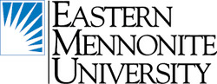
- Eastern Mennonite University. Master’s degree, graduate certificate or professional development in Restorative Justice. Online, hybrid or in person. www.emu.edu/cjp

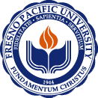
- Fresno Pacific University. They offer a Master's of Arts in Peacemaking & Conflict Studies. They offer a 10-14 unit Restorative Justice Concentration https://www.fresno.edu/programs-majors/graduate/peacemaking-and-conflict-studies

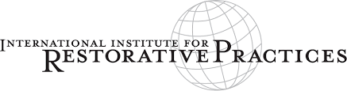
- International Institute for Restorative Practices. Master of Science and Graduate Certificate in Restorative Practices. www.iirp.edu Contact Jamie Kaintz, Director of Student Services at jamiekaintz@iirp.edu or 610-807-9221.

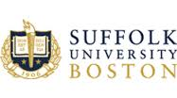
- Suffolk University Boston, Center for Restorative Justice, Professional Certificate in Restorative Justice Practices online and intensive residency. New July 2021. https://www.suffolk.edu/cas/centers-institutes/center-for-restorative-justice

The University of Maine (Online) Restorative Practices Certificate Program Six days online for 900.00. https://calendar.umaine.edu/event/online-restorative-practices-certificate-program

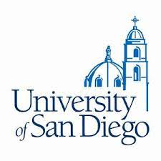
University of San Diego, Restorative Justice Facilitation and Leadership Certificate. This nine-unit certificate program is for people wishing to deepen their understanding of restorative justice, become skillful restorative facilitators, and lead efforts to implement Restorative Justice programs and policies. https://pce.sandiego.edu/public/category/courseCategoryCertificateProfile.do?method=load&certificateId=48262350&selectedProgramAreaId=16306&selectedProgramStreamId=

Simon Fraser University, Canada. Three class online certificate. The Restorative Justice Certificate is for anyone looking for a new way of helping people deal with harm. The theory and tools will help you whether you're a parent or family member dealing with bullying, or a professional tasked with facilitating justice or conflict resolution. https://www.sfu.ca/continuing-studies/programs/certificate-in-restorative-justice/why-this-program.html

